web701 Assessment

Design for and Evaluate web technologies to develop a website.

Caleb Eason

Table of Contents

Milestone 1: Design 2

1 Website Brief 2

2 Requirements 3

2.1 Site Goals 3

2.2 User Experience 3

2.2.1 Intended Audience 3

2.2.2 Scenarios 3

2.2.3 Competitive Analysis 4

2.3 Site Content 11

2.3.1 Functional Requirements 11

2.3.2 Content Grouping 12

2.4 Site Structure 13

2.4.1 Metaphors 13

2.4.2 Site Structure Listing 13

2.4.3 Architectural Blueprint 13

2.4.4 Visual Design 14

3 Agile Development 21

3.1 User Stories and Feature List 21

3.2 CRUD Analysis 22

4 References 23

Milestone 1: Design

# Website Brief

The members of the Nelson Disaster Relief Charity (NDR) are interested in having a website of their own. Read the following brief description on the proposed website:

The Nelson Disaster Relief Charity is a disaster relief style charity in the Nelson region who offer shelter and food to people displaced by natural disasters.

We need a website for the Nelson region for members of the charity to provide relief and shelter during natural disasters.

The purpose of the new website is to help with the funding and distribution of disaster relief services by members of our charity to beneficiaries. The website lets members register and describe the relief services they are providing, specifying the number and frequency of the offerings.

The website lets members of the community (beneficiaries) access the service, by providing tokens that can be “spent” in the service. To achieve our goal, we would like to have an online token function on our website that lets a beneficiary access a limited number of tokens, for example the system needs a mechanism that verifies that a member of the community is accessing the service and that the token belongs to a particular community member. The website needs some homepage text about general information of our products and services such as: types, characteristics, quality factor, usage and benefit.

We require the following features on the website:

1.   Charity members and beneficiaries can register, log in and administer their own accounts.

2.   Members use the website to register their products and services, and beneficiaries use the system to acquire tokens.

3.   Interactive element(s) that engages the website user.

4.   The system provides an interface that the members can use to accept a token in a transaction

# Requirements

## Site Goals

This website will provide an online platform for the Nelson Disaster Relief charity (NDR) to fund and distribute their services. The mission statement of NDR is to provide shelter and aid to Nelsonians during times of crisis. The short-term goals of the website are to provide an online resource for charity members to distribute their services to charity beneficiaries as an addition to their existing methods (office consultations, phone calls). The long term goal of the website is to become the primary method for charity members and beneficiaries to create, fund, and purchase services. The Charity is aiming to be able to support up to 500 residents during a disaster through their website.

The intended audience for this website can be divided into two main groups, charity members who will come to the website to register charity services, and charity beneficiary who will come to the website to purchase services using tokens.

## User Experience

### Intended Audience

This website is targeted towards two audiences who will use the website in different ways. The primary audience is charity beneficiaries. These users will come to the website to purchase charity services in times of crises. This group will consist of Nelson residents displaced by a disaster, likely including parents, caregivers, community leaders, and individuals. The second audience for this website is charity members. These are NDR staff who will use the website to register and describe services offered by the charity.

### Scenarios

The website will be used to provision emergency food supplies during a disaster. An example beneficiary for this service could be a school teacher caring for students during a disaster. This school teacher will need to use NDR’s website to provision rations for themself and the students under their care.

*Tim is a school teacher at a Nelson primary school. During a Severe flood, some students are unable to get home. Tim needs NDR’s help and wants to use their website to provision food for him and the children while they shelter at the school.*

Another use case of the website could be a parent finding shelter for their family when evacuating their home. The parent will need to use the website to find and acquire emergency shelter for them and their dependants. As they have been displaced from their home, they will likely be using their phone to access the website.

*Lara’s house was destroyed in an earthquake, leaving her and her family with nowhere to stay. Lara wants to use NDR’s website to find shelter for her family. Her laptop was destroyed in the earthquake, so she can only use her mobile phone to access the service.*

Another scenario is an employee of NDR using the website to register a new service. The employee would need to use the website to register and describe their new service, enabling beneficiaries to access the service through the NDR website.

*Lucy is an employee of NDR. She has been working to develop a new service for beneficiaries of NDR. Lucy wants to register her new service on the NDR website alongside the existing services.*

### Competitive Analysis

Three similar websites were analysed to find common trends in this type of website and identify good and bad practice.

#### Medicine Sans Frontiers (Doctors without Borders)

Analysed website by Medicine Sans Frontiers (retrieved 2025).

The Medicine Sans Frontiers (MSF) website has the following hierarchy for the significant pages on their website.

* Home (starting page)
* Stories and News
  + Stories from patients & staff
  + News from our projects
  + Statements & opinion
  + Media coverage
  + Media contacts
* Our Work
  + How we work
  + Where we work
  + Our medical approach
  + Reports & publications
* About Us
  + MSF New Zealand
  + Our finances
* Get Involved
  + Fundraise for us
  + Social media
  + Attend an event
  + Gifts in wills
* Join our Team
  + Work overseas
  + Work in the office
  + Volunteer in the office
* Donate
  + Major Donors
  + Other ways to donate
  + Impact of your donation
  + Supporter promise
  + FAQs
  + Update your details

This organisation groups website areas by a category, keeping navigation easy and intuitive.

The *Home* page features a horizontal navigation menu in the page header, a well-established convention of modern web design. The main banner of the page displays some information on current humanitarian affairs supported by MSF. The home page is presented with a simple colour theme with red highlights. A simple visual hierarchy is used to keep the page readable and navigable.

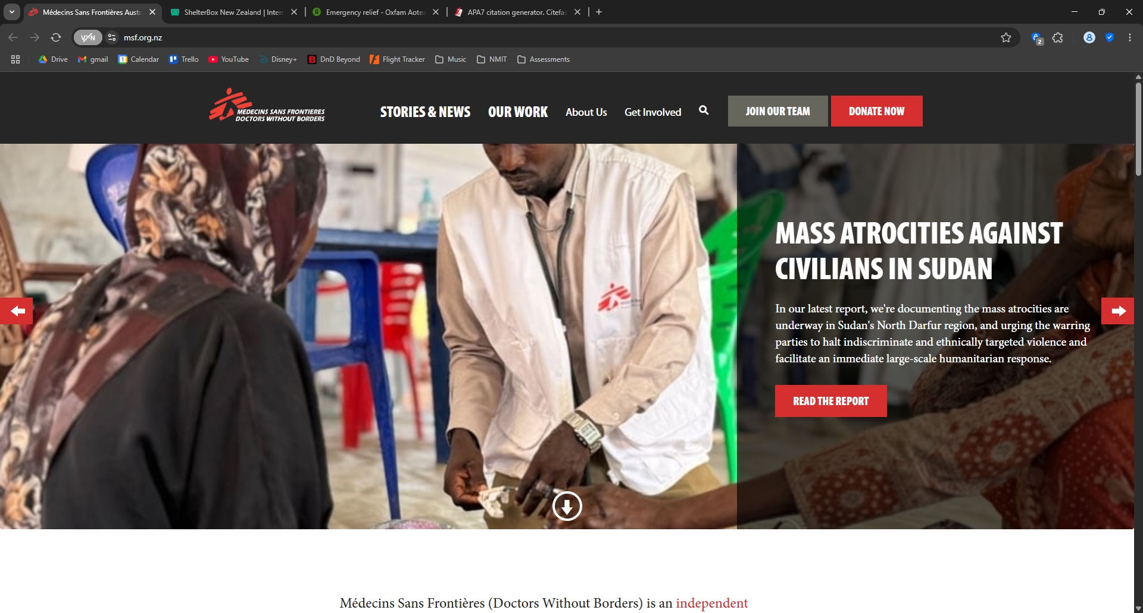

Scrolling down further shows a large banner split in two with links to the *Join out Team* and *Donate* pages. These banners present a clear call to action to the viewer, effectively conveying how they can support the charity. The visual design makes this section stand out, ensuring the user does not miss it. The same approach is used with the button links to these pages in the page header.

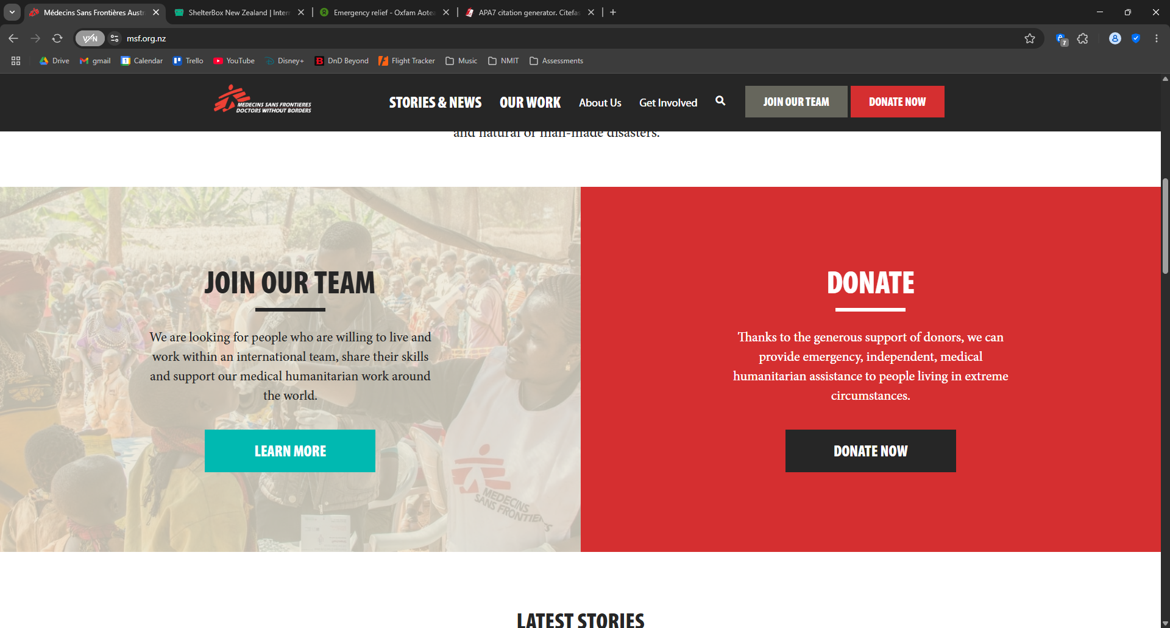

The website uses the same visual style and layout conventions across all its pages. The same header and footer are used on all pages. This consistency throughout the website makes for a great user experience, keeping the page easily navigable and visually appealing. A clear visual hierarchy makes important sections stand out, grabbing the user’s attention. The page footer presents all the same links and categories displayed in the header in an expanded format.

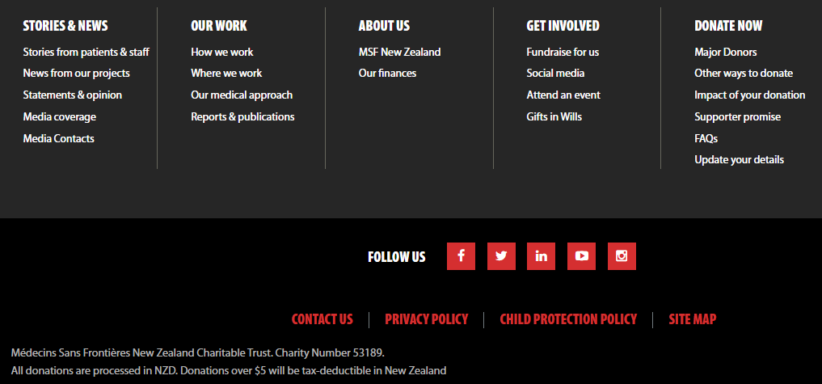

The sites uses images impactfully, showing pictures of real people affected by the crises MSF provides relief for.

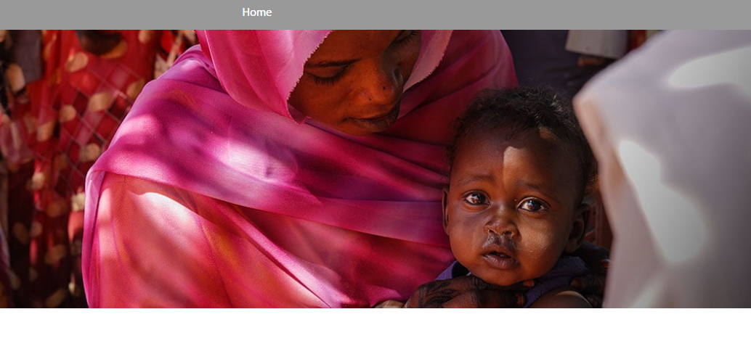

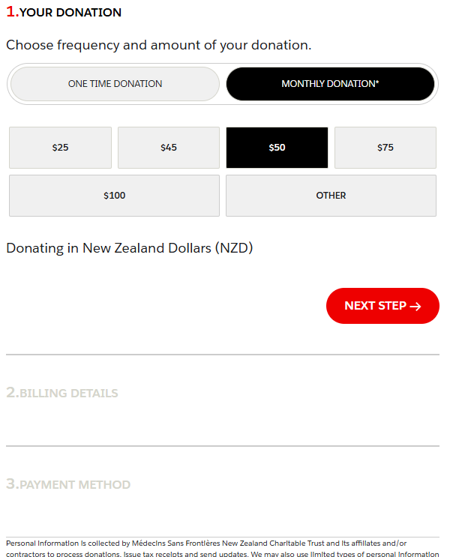The donation payment menu clearly communicates the specifics of payment. Distinguishing between one time and monthly payments, providing some suggested donation amounts, and specifying that the website uses New Zealand currency. The only potential drawback of this implementation is that monthly donation is selected by default. This could deter some potential donators who may be stringent with money.

#### ShelterBox

Analysed website by ShelterBox (2025).

The ShelterBox website uses similar design conventions to MSF, but the visuals lack polish and some of the functionality is a bit clunky. The home page uses a similar design with a vertical navigation menu in the page header and a banner showing a recent story. A green button is used for the link to their *Dontate* page to make the link stand out as a call to action to the viewing, but it is not vertically centred. The home page shows a summary of their achievements in 2024, which is a good way to build confidence in the organisation.

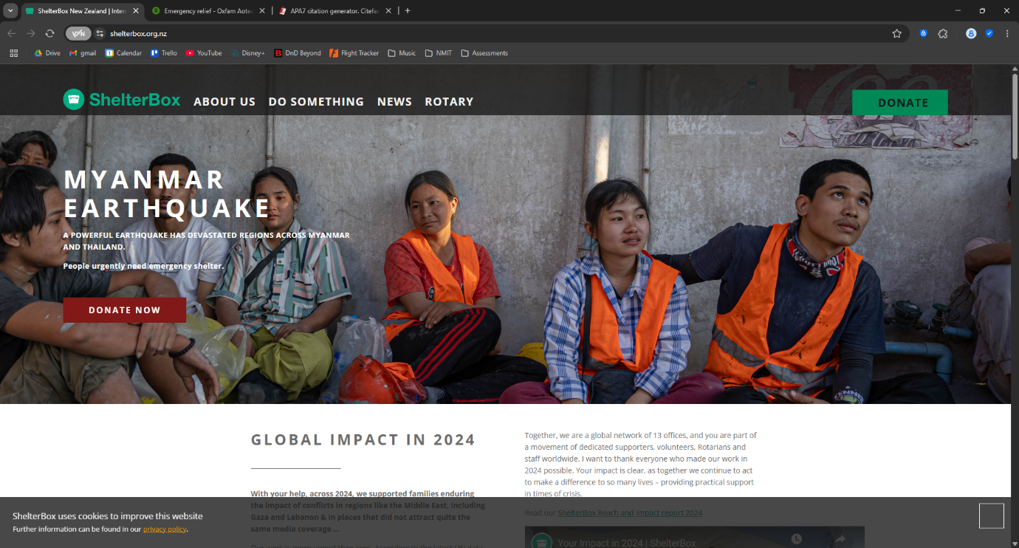

The website uses compelling images, like MSF, but some are of low quality.

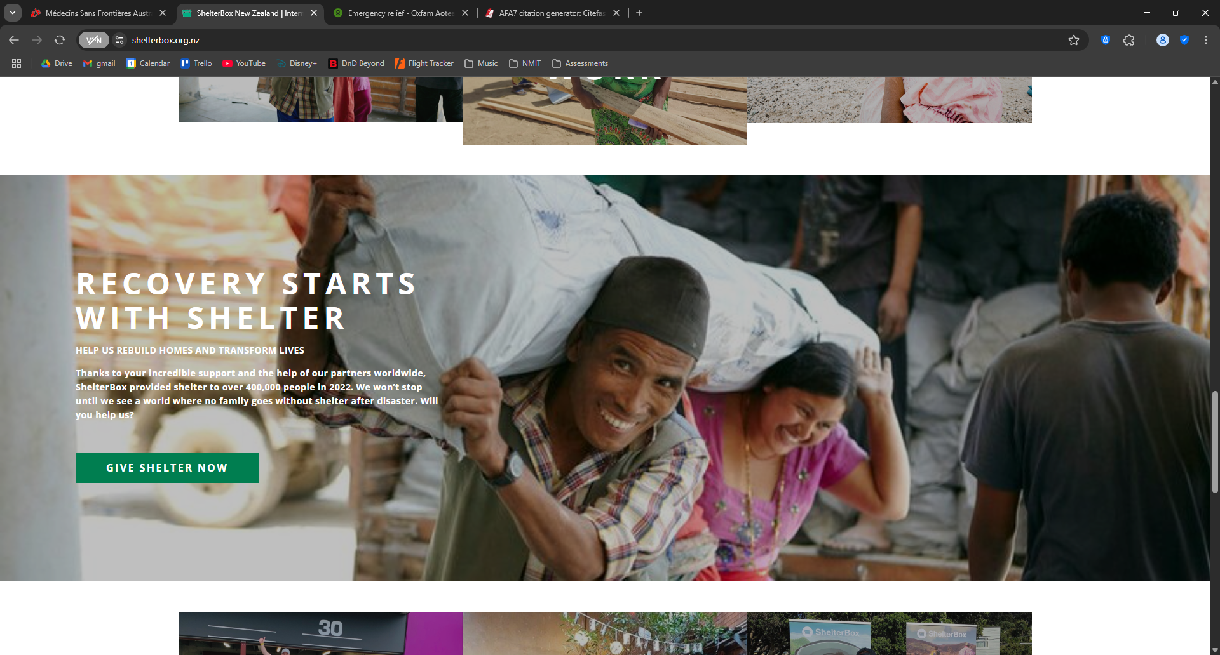

The dropdown menu for the subpages in each category is somewhat unconventional. The page links shows in the dropdown look like they should be headers for a lists, and not clickable links themselves. The user also can not click on the main links in each page, they have to select a sub page from the dropdown.



The footer presents some of the links shown in the page header, but the categories are different, with some pages excluded and some extra links added which do not appear in the header. This disconnect between the two navigation menus harms navigability as the reader may not think to check the two menus if they can’t immediately find what there are looking for in one.

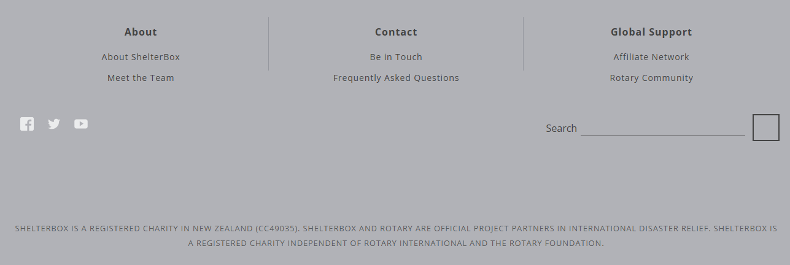

The overall inconsistency and lack of visual polish harms the effectiveness of the website. As it stands, the poor attention to detail could deter potential donors that may judge the organisation by the presentation of their website.

One thing the website does better than the MSF website is the donation form. The form provides some set donation amounts, but couples them with the user can fund with a set donation. This makes the user’s donation feel more impactful by describing a tangible result of the donation.

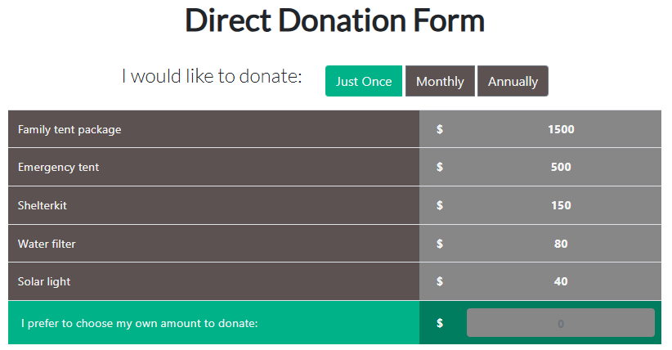

#### Oxfam Aotearoa

Analysed website by Oxfam Aotearoa (2023)

Oxfam Aotearoa’s (OA) website has a different visual design to MSF and ShelterBox, but uses a low of the same conventions for site layout and navigation. The page features a vertical navigation menu in the page header, though it is divided into two sections. Like the other two websites, the *Donate* page link stands out, providing a clear call to action.

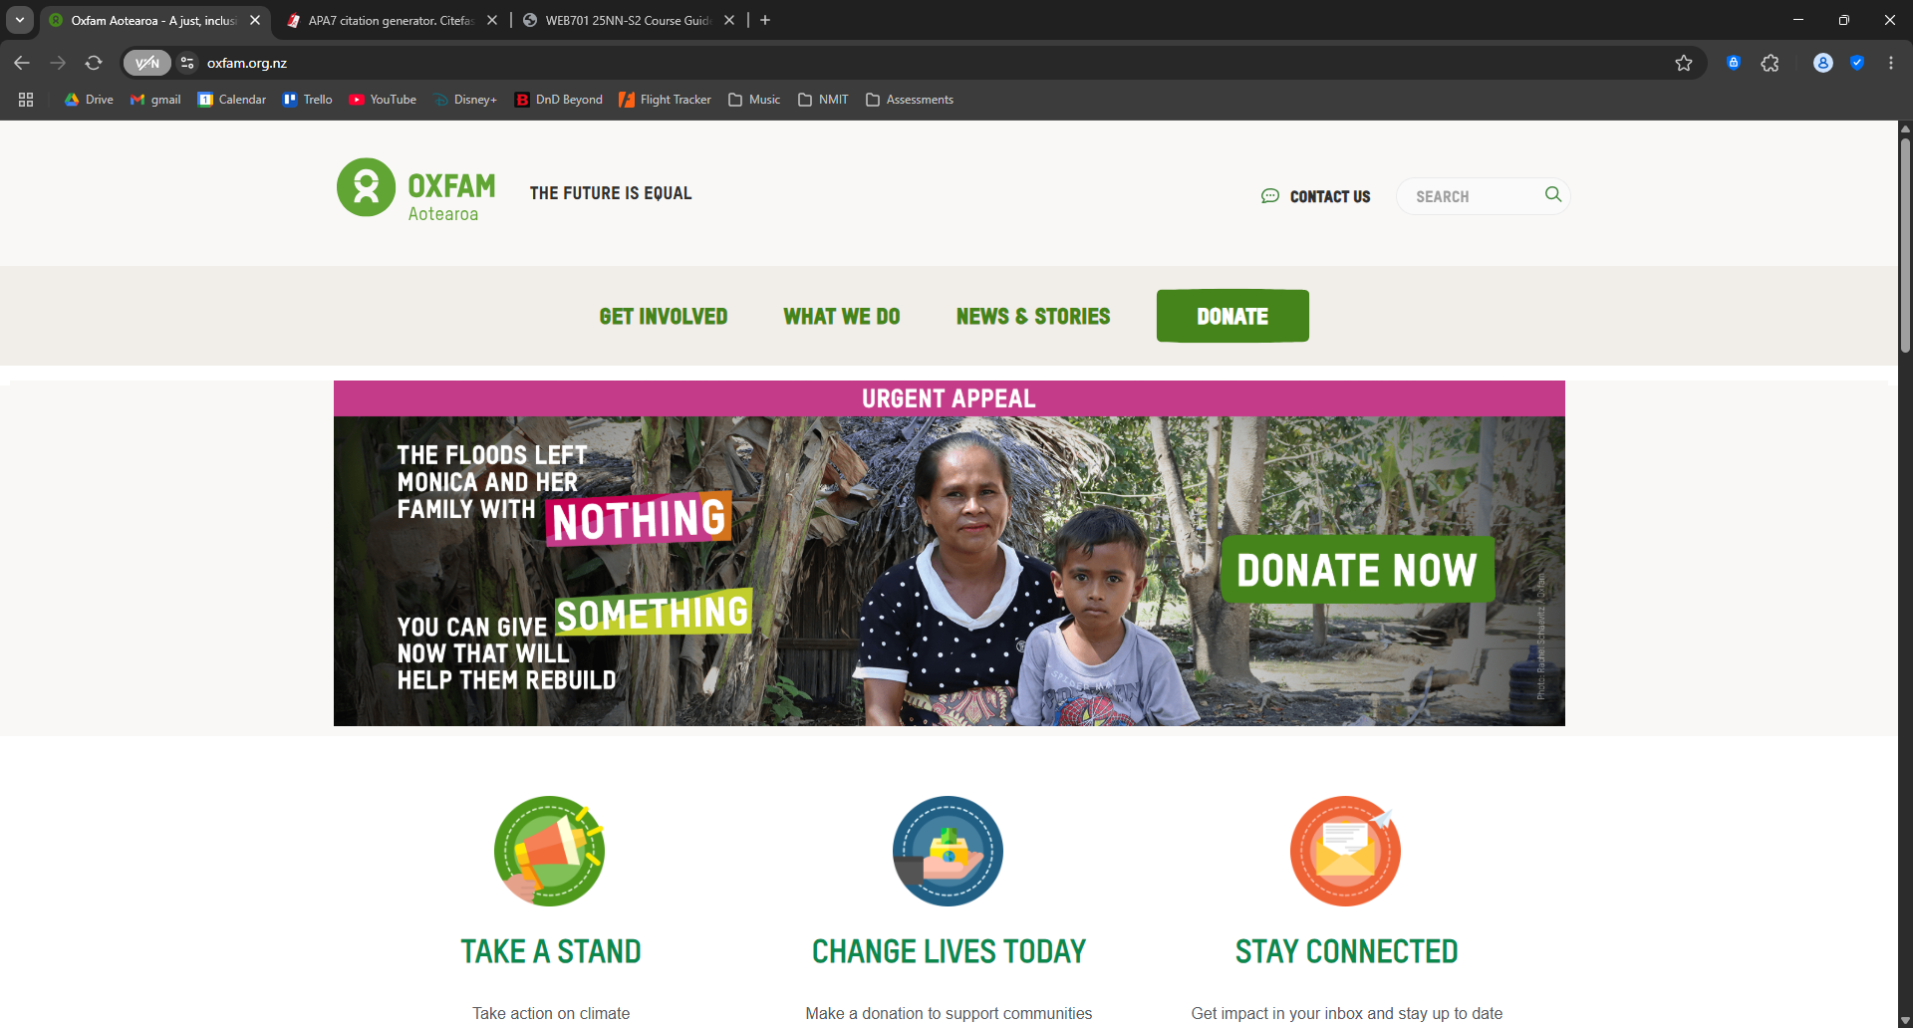

Below the header, the home page presents some compelling calls to action. The page banner shows an image of a family impacted by a flood, and directly asks the user to help them, an effective call to action with a clear link to the donate page. Below the banner, three captioned pictograms provide further calls to action.

The websites footer contains a small selection of links to other pages as well as a description of the OA charity. Like the ShelterBox website, the footer introduces some new links which are not present in the header navigation menu, but for the most part these are only minor pages. All the important pages linked here are also present in the header navigation menu, keeping the page easily navigable.

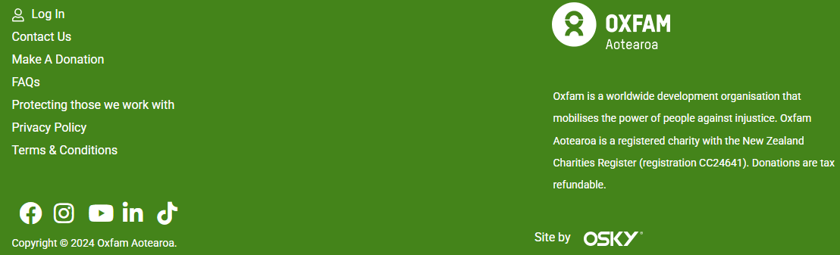

The website provides a similar donation menu to MSF. Though the functionality is expanded by enabling the user to make donations to specific funds as well as general donation to the charity.

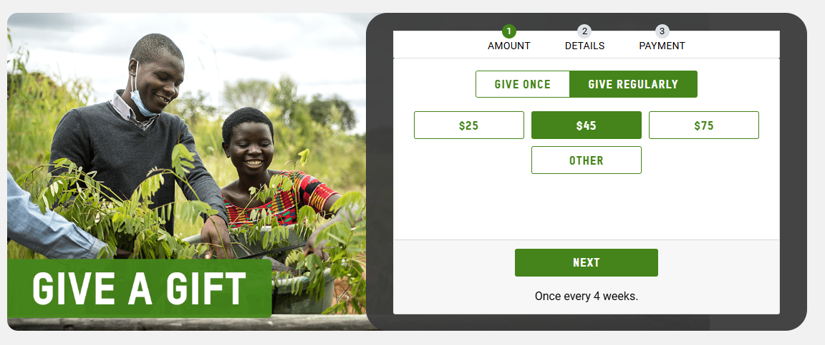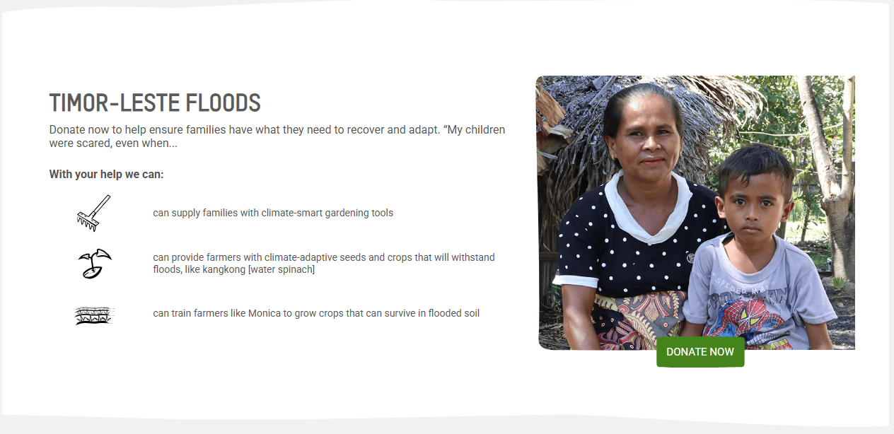

## Site Content

The site will include the following content:

* Description of the charity
* Compelling images of charity impacts
* Compelling images of people affected by disasters in Nelson
* Login form
* Register form
* Account management form
* Product registration form for charity members
* Token acquiring form
* Token balance for beneficiaries
* Service purchase form for charity beneficiaries
* Transaction acceptance form for charity members
* Header navigation menu
* Footer navigation menu
* Charity contact details
* Page links
* Charity logo
* Brief legal information
* Long legal information
* Phone number
* Email address
* Physical locations
* List of charity services

### Functional Requirements

The site must satisfy the following requirements:

* Charity members and beneficiaries must be able register, login to, and manage their own accounts.
* Members must be able to register their products and services on the website.
* Beneficiaries must be able to acquire tokens from the system and spend them on services.
* Interactive element(s) must be used to engages the website user.
* The system must provide an interface that the members can use to accept a token in a transaction

### Content Grouping

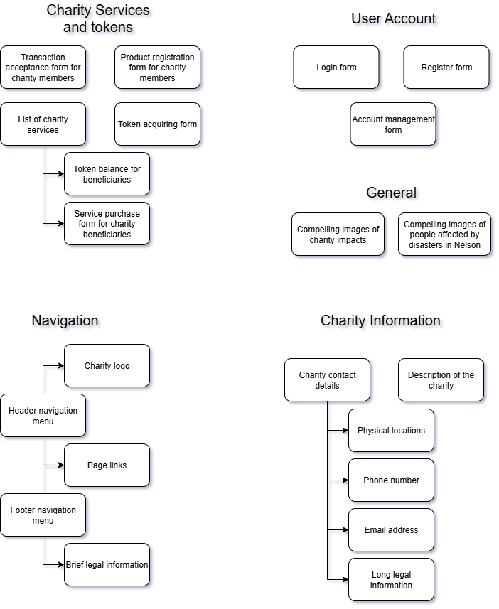

## Site Structure

### Metaphors

The application will use the organisational metaphor of a marketplace to present charity services in a digital catalogue. This will mirror the layout and structure of physical product catalogues in a dynamic web environment. Charity services can be categorised by their type (e.g. food or shelter) and will be priced using the token system.

The application will use the functional metaphor of ‘tokens’ to represent the abstract digital currency beneficiaries use to purchase charity services. These tokens do not directly equate to any real-world objects, they are simply an understandable metaphor to represent currency units.

The application can use various iconography as visual metaphors. Tokens can be represented using a coin icon. Service type can be represented using a house icon for shelter and plate/cutlery icons for food.

### Site Structure Listing

* Home
* Login
  + Register
* My account
* About us
  + Who we are
  + Legal information
  + Contact us
* Services
  + Get tokens
  + Purchase service
* Member console
  + Pending transaction
  + Register service

### Architectural Blueprint

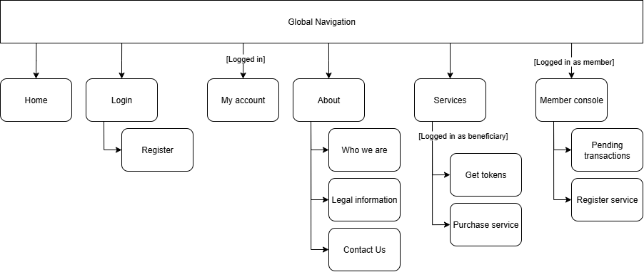

### Visual Design

#### Home

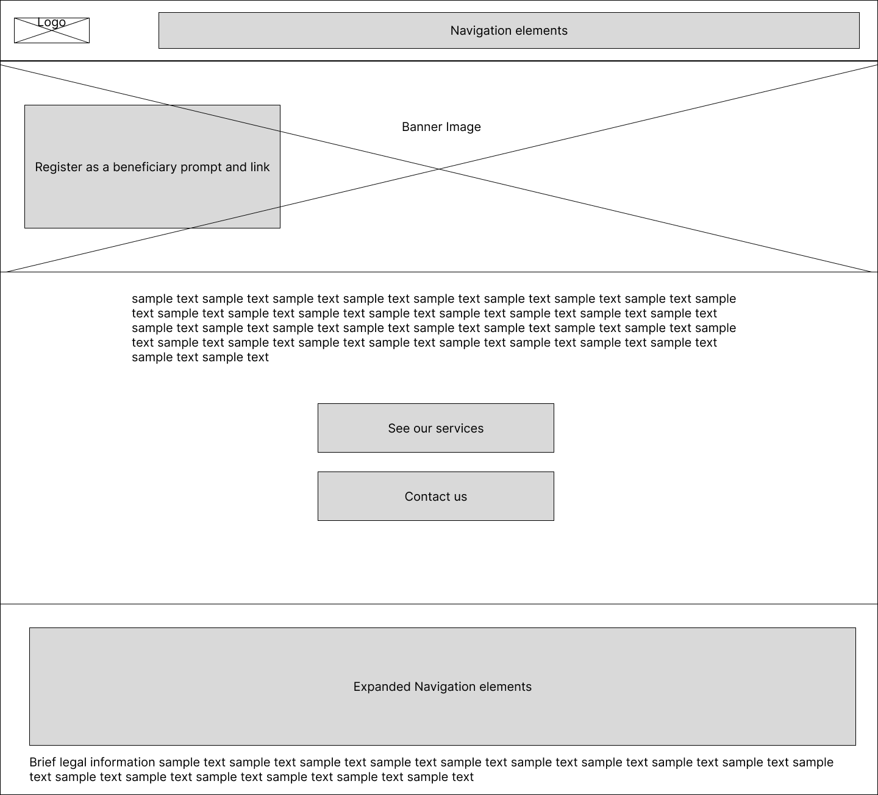

#### Login

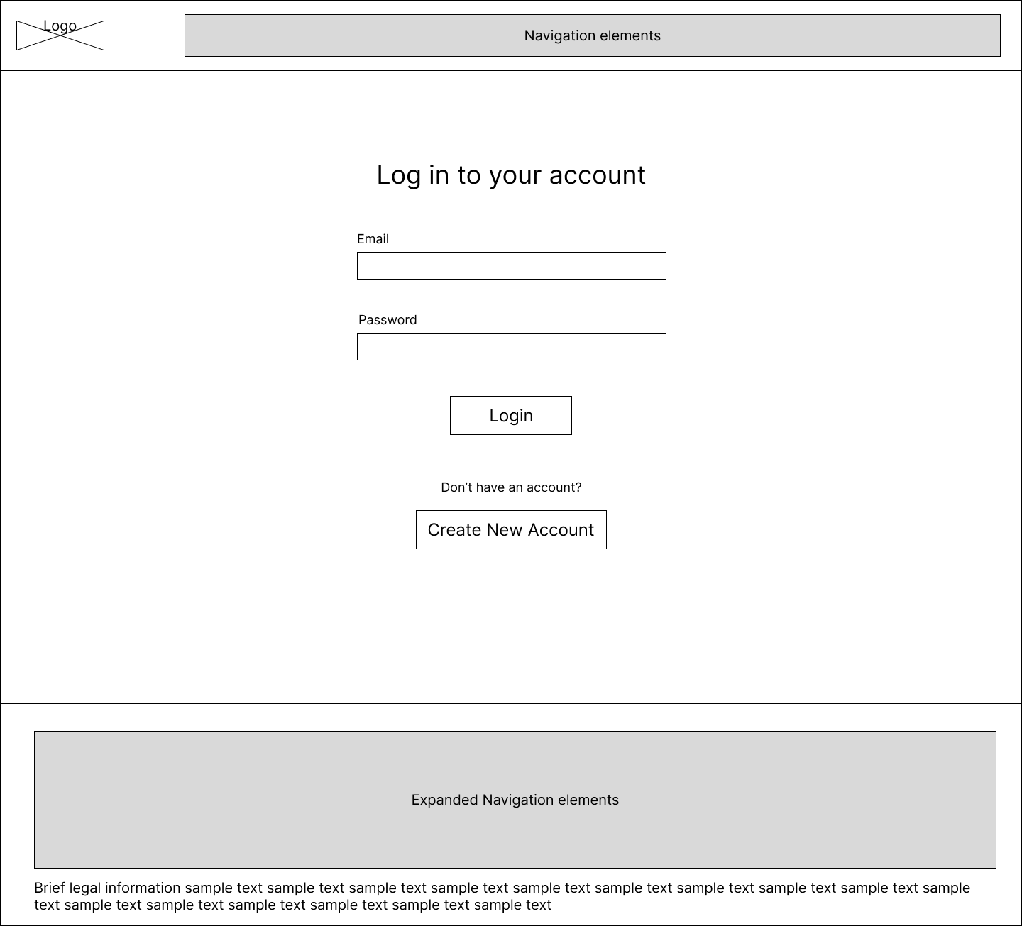

#### Register

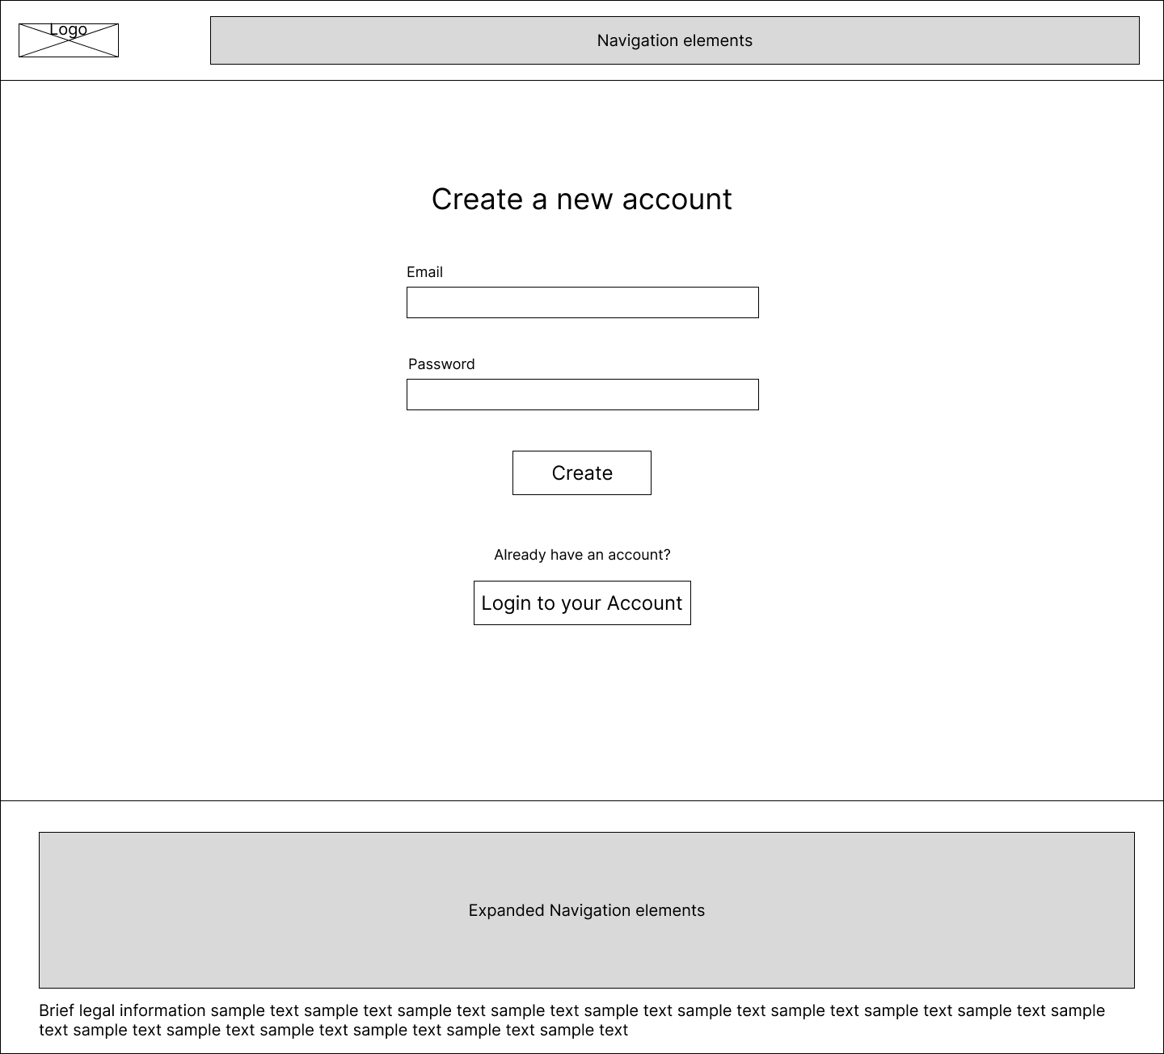

#### My Account

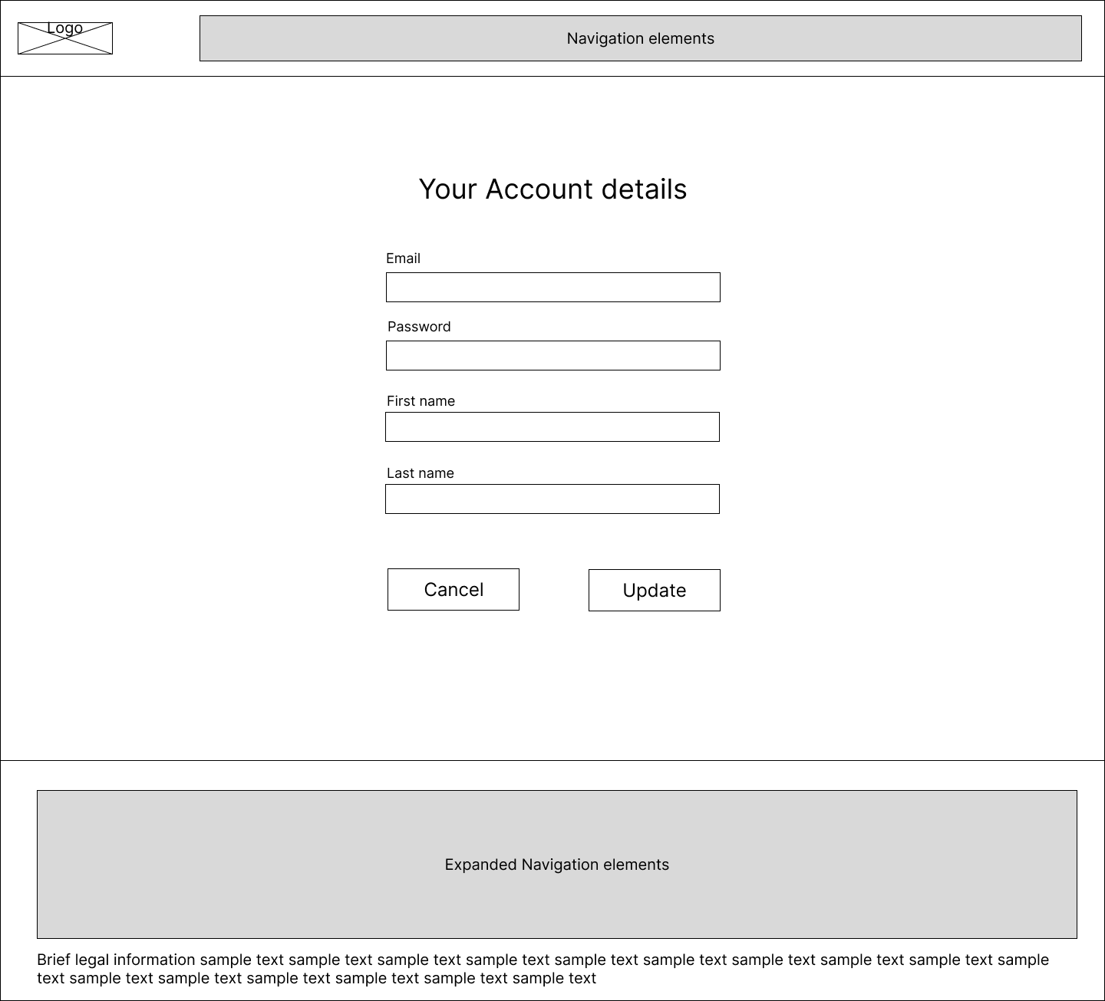

#### About

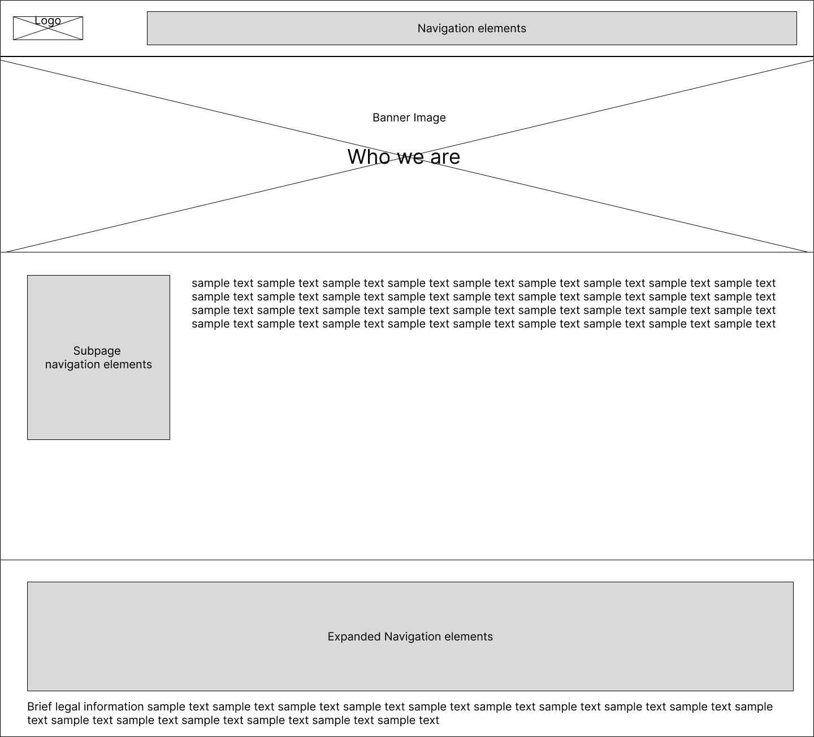

#### Services

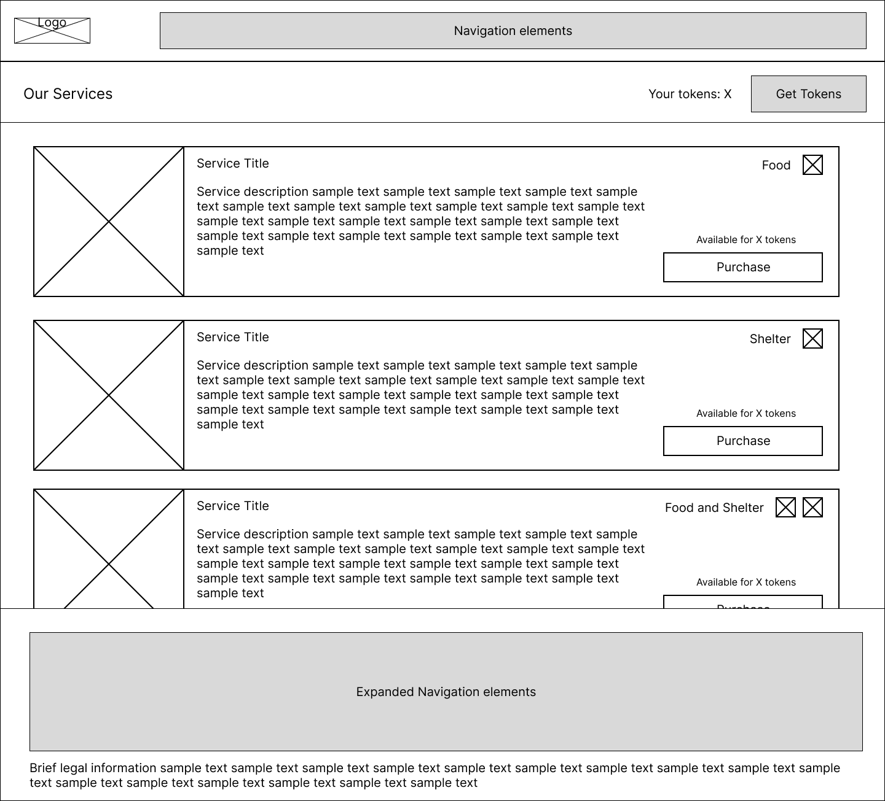

#### Register Service

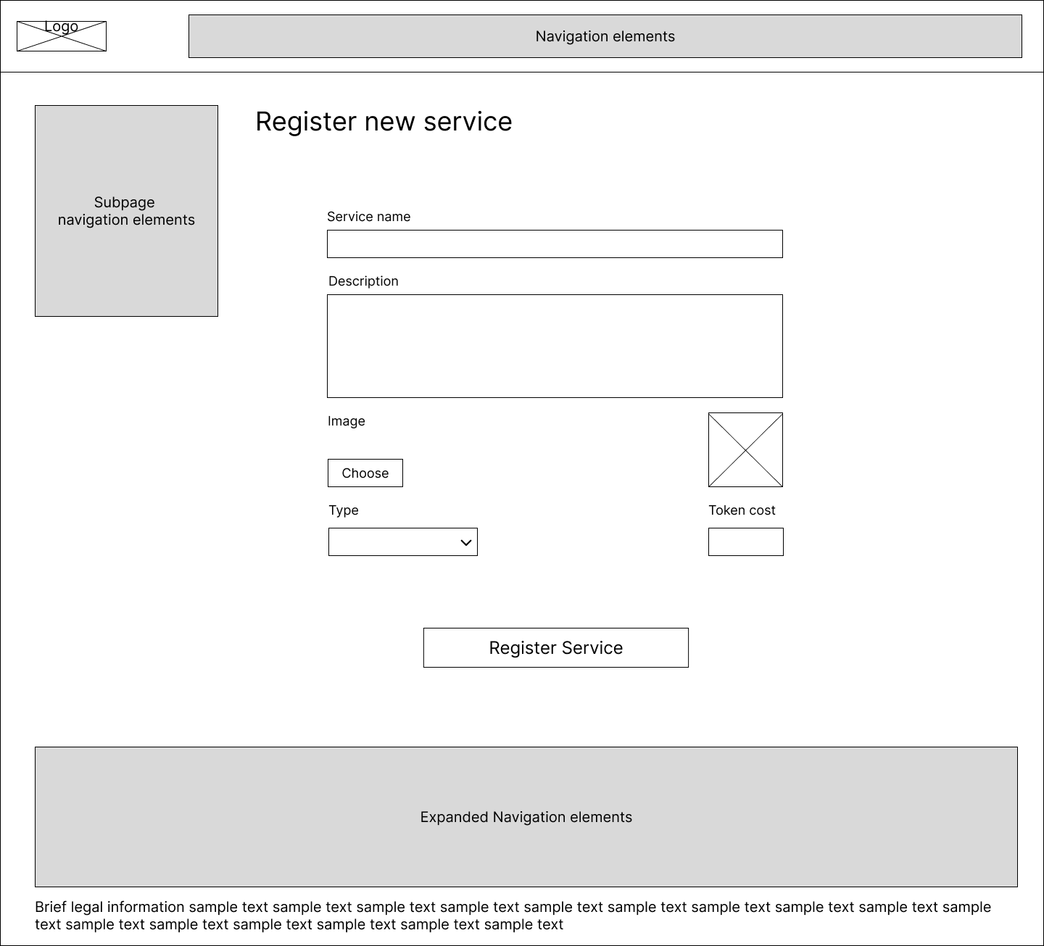

# Agile Development

## User Stories and Feature List

* *As a user, I need to be able to login to my account, so I can access services and manage my details.*
  + Login page
  + Registration page
  + Account management page
* *As a member, I need to register new services on the website, so beneficiaries can access them.*
  + Member console page
  + Register service page
* *As a beneficiary, I need to get charity tokens, so I can spend them on services during a disaster.*
  + Get tokens page
* *As a beneficiary, I need to purchase charity services, so I can receive assistance during a disaster.*
  + Services page
  + Purchase service page
* *As a member, I need to accept tokens in a transaction, so beneficiaries can receive the services they need.*
  + Pending transactions page
* *As a beneficiary, I want to know some information about the charity, so I know if I should sign up.*
  + About page
  + Who we are page
  + Legal information page
* *As a beneficiary, I want to know contact details of the charity.*
  + Contact us page
* *As a user, I need a place to land when first entering the website.*
  + Home page

## CRUD Analysis

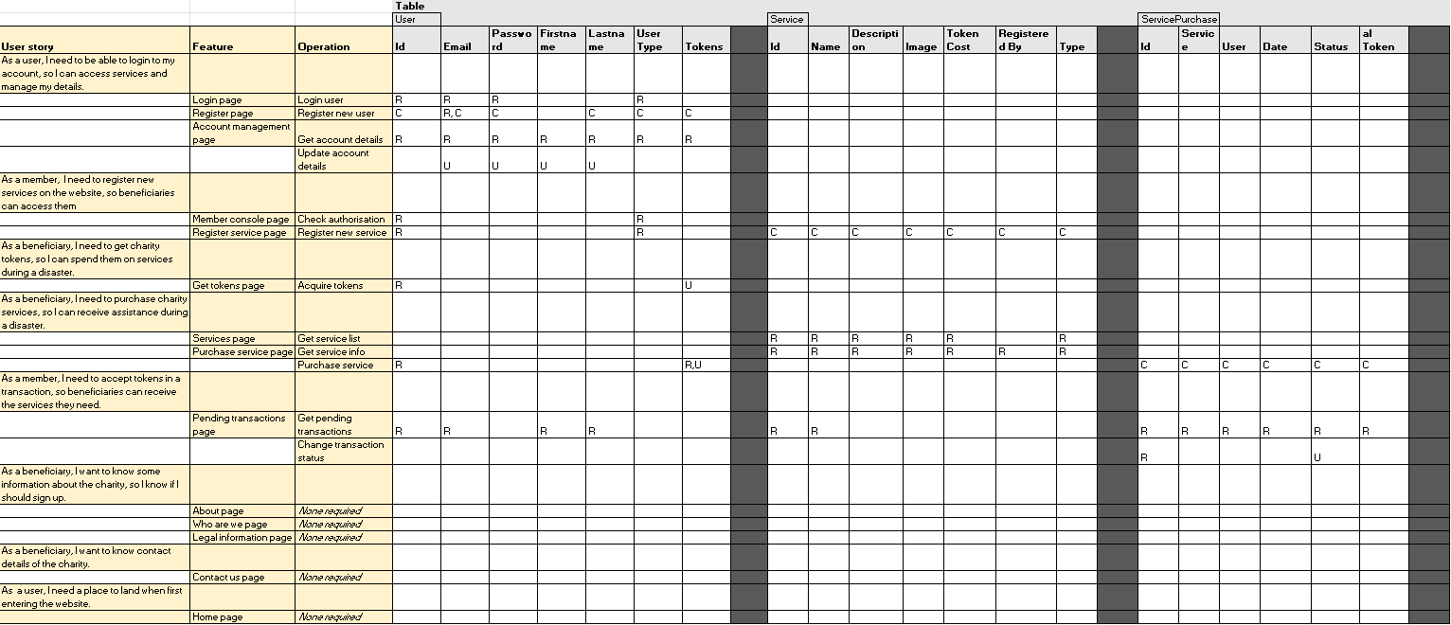

Refer to the file WEB701-A1-CrudAnalysis for a clearer picture.

# References

Medicine Sans Frontiers. (n.d.). Médecins Sans Frontières Australia. Retrieved August 7, 2025, from <https://msf.org.nz/>

Oxfam. (2023, September 27). Oxfam Aotearoa. <https://www.oxfam.org.nz/>

ShelterBox. (2025, June 10). ShelterBox New Zealand. Retrieved August 7, 2025, from <https://www.shelterbox.org.nz/>